SIMATS ENGINEERING
NAME: A.Preetika Sudhakar
RREG NO. 192371073
COURSE NAME: Database Management Systems
COURSE CODE: CSA0501

DDL Commands – CREATE, ALTER, DROP
AIM:
To Create, Alter, Drop, Rename, Truncate using Data Definition Language (DDL) statements.
Description:
Data Definition Language (DDL) statements are used to define the database structure or schema.
DDL Commands: Create, Alter, Drop, Rename, Truncate
CREATE:
CREATE DATABASE house_plotting;
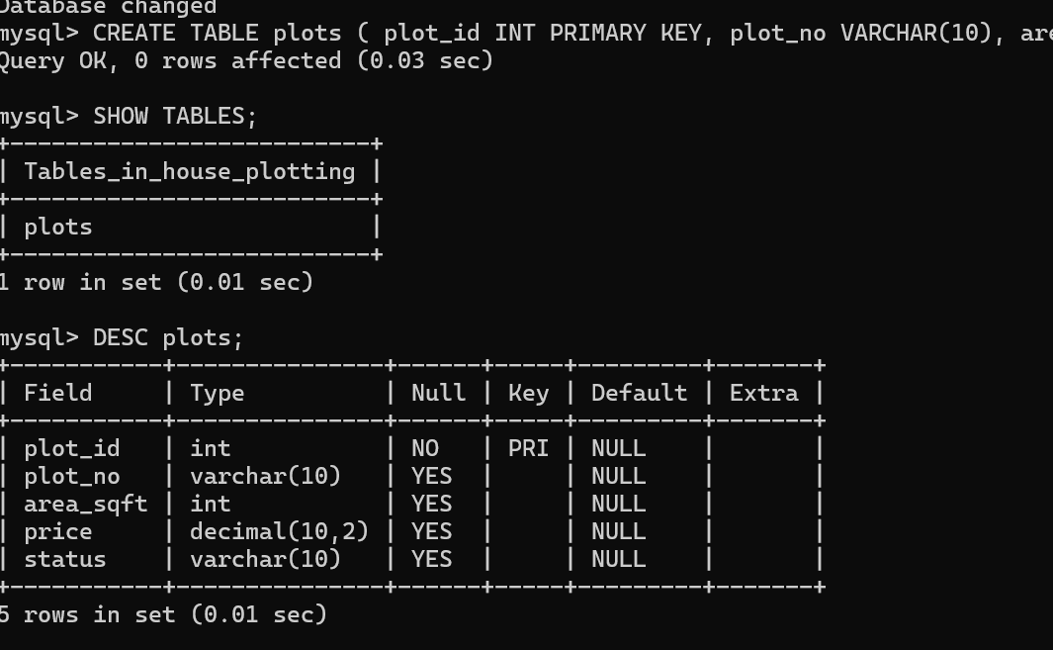

ALTER: - alters the structure of the database
ALTER TABLE plots ADD location VARCHAR(20);
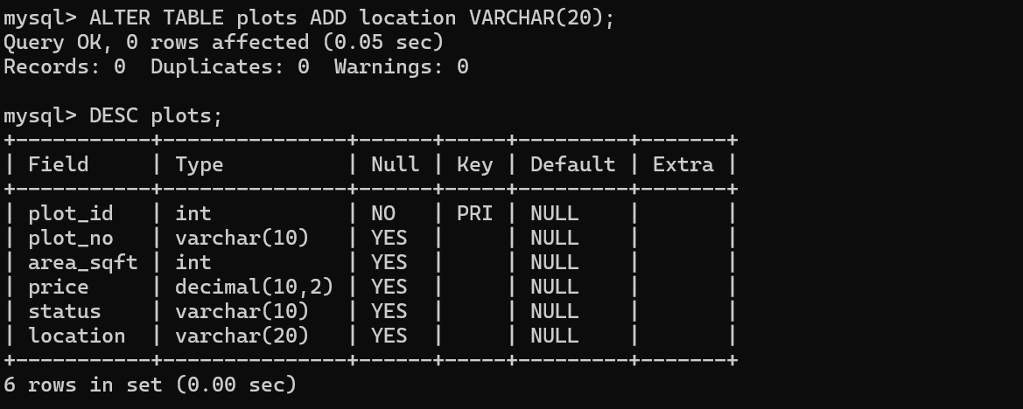

DROP:
ALTER TABLE PLOTS DROP COLUMN OwnerName;
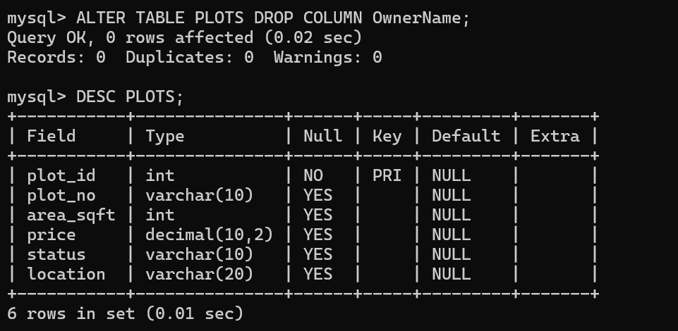

TRUNCATE:
TRUNCATE TABLE plots;
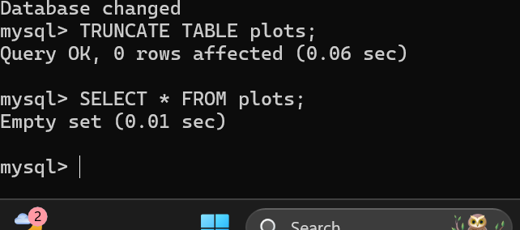

RENAME:
RENAME TABLE HOUSE_PLOTS TO PLOTS;
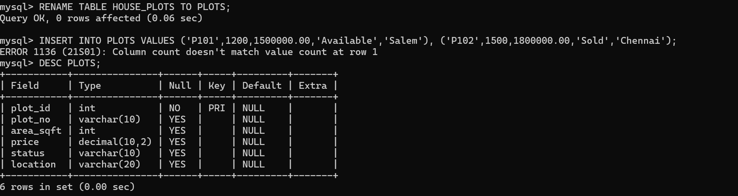

RESULT:
Tables are created, altered and modified using DDL commands.

